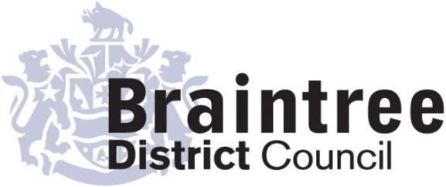
Equality Impact Assessment

This impact assessment considers positive, negative or no impact on each of the 9 protected characteristics in relation to addressing the 3 aims of the Equality Duty that we as a public body must give due regard to;
- Eliminate unlawful discrimination, harassment and victimisation and other conduct prohibited by the Act.
- Advance equality of opportunity between people who share a protected characteristic and those who do not.
- Foster good relations between people who share a protected characteristic and those who do not.
Housing and Community
Directorate
Service
Housing
Title of policy, strategy, project or service
Homelessness Strategy 2018-2023

Is the policy, strategy, project or service;
Existing New/proposed Changed/Reviewed

Q 1. Aim of the policy, strategy, project or service
Local Authorities are required to carry out a homelessness review, formulate and publish a strategy. The Strategy seeks to prevent homelessness and to improve how we seek to alleviate it.

Q 2. Who is this policy, strategy, project or service going to benefit or have a detrimental impact
on & how?
The Strategy is intended to improve how we deal with anyone at risk of or becoming homeless. It does not have a detrimental impact.

Q3. Is this policy, strategy, project or service aimed at one of the protected characteristics?
If so, what justification is there for this?

The Strategy is not aimed at one of the protected characteristics.

Q 4. Thinking about each of the protected characteristics does or could the policy, strategy,
project or service have a negative or positive impact?

Group | Negative | Positive/  No impact | Unclear
Age
Disability
Gender reassignment
Marriage & civil partnership (only in respect of eliminating unlawful discrimination).
Pregnancy & maternity
Race
Religion or belief
Sex
Sexual orientation
If the answer for any group is ‘negative’ or ‘unclear’ do a full EIA
Q5. Thinking about each of the protected characteristics does or could the policy, strategy,
project or service help to support the 3 aims of the Equality Duty?

Group | Yes | No | Unclear
Age
Disability
Gender reassignment
Marriage & civil partnership (only in respect of eliminating unlawful discrimination).
Pregnancy & maternity
Race
Religion or belief
Sex
Sexual orientation
If the answer for any group is ‘no’ do a full EIA

Q 6. What evidence has been used (e.g. data, feedback, consultation & engagement, surveys) that may influence the policy, strategy, project or service?

Group | Evidence
Age | Our main source of data is the Housing Register. It shows that older people in the District at risk of homelessness are more likely to be housed in the social sector before they become homeless than the rest of the population.
Disability | Our data shows that we target access to suitable adapted housing to people with physical disabilities. The Strategy includes plans to assist people with mental health conditions to access suitable housing and/or support.
Gender reassignment | No specific evidence
Pregnancy & maternity | Homelessness law gives priority to pregnant mothers and households with children. Our Strategy includes ‘housing pathways’ specifically for families and pregnant mothers.
Race | A higher proportion of people from minority ethnic groups are registered for housing than in the population as a whole.
Religion or belief | We monitor the religion of applicants to the Housing Register and people who approach us as homeless.
Sex | Homelessness legislation gives priority to families with dependent children. Women are more likely to be the main carer for children and so the lead applicant is more likely to be female.  We also help people who are experiencing domestic abuse. Again, this is more likely to be women than men.
Sexual orientation | Applicants are asked their sexual orientation as they apply for assistance.

Q 7. Using the responses to questions 4 & 5 should a full EIA be carried out on this
policy, strategy, project or service?

Yes No

Provide your reasons for your response showing how you have considered due regard
All of the protected characteristics are monitored for all homeless households that complete a housing application (which is almost all applicants). Generally, the Homelessness Strategy is seeking to address disadvantage and assist people who are most vulnerable. The Strategy commits us to set out ‘Housing Pathways’ for a number of groups with protected characteristics, such as people with disabilities and pregnant mothers.

Completed by (Print name):
Tim Lucas
Signature :
Chris Fleetham
Approved by Head of Service (print name):
Signature :
16th August 2018
Date:

