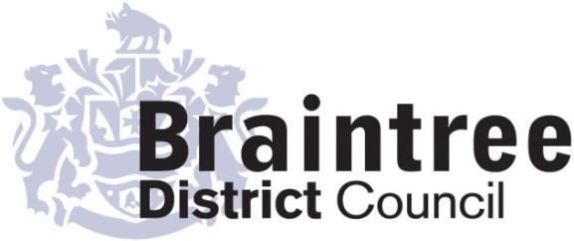
Equality Impact Assessment
Basic

This basic impact assessment is an initial screening process to help identify if a full Equality Impact Assessment is required and, if it isn’t, to record the reasons why.
It considers positive, negative or no impact on each of the 9 protected characteristics in relation to addressing the 3 aims of the Equality Duty that we as a public body must give due regard to;
- Eliminate unlawful discrimination, harassment and victimisation and other conduct prohibited by the Act.
- Advance equality of opportunity between people who share a protected characteristic and those who do not.
- Foster good relations between people who share a protected characteristic and those who do not.
Governance and Legal
Directorate
Service
Governance and Members
Title of policy, strategy, project or service
Councillor Allowance Scheme

Is the policy, strategy, project or service;
Existing New/proposed Changed/Reviewed
√

Q 1. Aim of the policy, strategy, project or service
To provide a framework for Member Allowances

Q 2. Who is this policy, strategy, project or service going to benefit or have a detrimental impact
on & how?
The framework governs the allowances payable to Members of the District Council. It impacts on all elected Members.

Q3. Is this policy, strategy, project or service aimed at one of the protected characteristics?
If so, what justification is there for this?

No

Q 4. Thinking about each of the protected characteristics does or could the policy, strategy,
project or service have a negative or positive impact?

Group | Negative | Positive/  No impact | Unclear
Age |  | √
Disability |  | √
Gender reassignment |  | √
Marriage & civil partnership (only in respect of eliminating unlawful discrimination). |  | √
Pregnancy & maternity |  | √
Race |  | √
Religion or belief |  | √
Sex |  | √
Sexual orientation |  | √
If the answer for any group is ‘negative’ or ‘unclear’ do a full EIA
Q5. Thinking about each of the protected characteristics does or could the policy, strategy,
project or service help to support the 3 aims of the Equality Duty?

Group | Yes | No | Unclear
Age | √
Disability | √
Gender reassignment | √
Marriage & civil partnership (only in respect of eliminating unlawful discrimination). | √
Pregnancy & maternity | √
Race | √
Religion or belief | √
Sex | √
Sexual orientation | √
If the answer for any group is ‘no’ do a full EIA

Q 6. What evidence has been used (e.g. data, feedback, consultation & engagement, surveys) that may influence the policy, strategy, project or service?

Group | Evidence
Age | ) The scheme has been developed based on the legislation,
Disability | ) statutory guidance, Member Surveys, Member Interviews
Gender reassignment | ) and comparison with other schemes.
Pregnancy & maternity | )
Race | )
Religion or belief | )
Sex | )
Sexual orientation | )

Q 7. Using the responses to questions 4 & 5 should a full EIA be carried out on this
policy, strategy, project or service?

Yes No
√

Provide your reasons for your response showing how you have considered due regard
In developing the scheme due regard has been given to ensuring all Members have equality of treatment and are not adversely impacted. Where potential impacts or risks were identified (such as dependants’ allowances) the scheme has been varied to remove this issue.

I Hunt
Completed by (Print name):
Signature :
I Hunt
Approved by Head of Service (print name):
Signature :
14 March 2019
Date:

