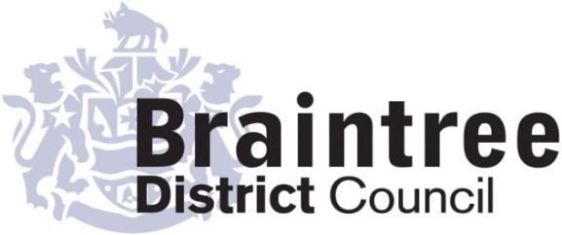
Equality Impact Assessment
Basic

This basic impact assessment is an initial screening process to help identify if a full Equality Impact Assessment is required and, if it isn’t, to record the reasons why.
It considers positive, negative or no impact on each of the 9 protected characteristics in relation to addressing the 3 aims of the Equality Duty that we as a public body must give due regard to;
- Eliminate unlawful discrimination, harassment and victimisation and other conduct prohibited by the Act.
- Advance equality of opportunity between people who share a protected characteristic and those who do not.
- Foster good relations between people who share a protected characteristic and those who do not.
Environment & Operations
Directorate
Service
Regulatory Services
Title of policy, strategy, project or service
Enforcement Policy Review

Is the policy, strategy, project or service;
Existing New/proposed Changed/Reviewed
X

Q 1. Aim of the policy, strategy, project or service
The Enforcement Policy review sets out the Council’s approach to securing compliance with regulatory requirements for which BDC is responsible and applies to all our regulatory functions (with the exception of Planning). The policy applies to services where the Council can enforce against a person, organisation or company to secure compliance with the law.

Q 2. Who is this policy, strategy, project or service going to benefit or have a detrimental impact
on & how?
Businesses, residents, workers and visitors to the District will benefit by being protected through the application of the Policy

Q3. Is this policy, strategy, project or service aimed at one of the protected characteristics?
If so, what justification is there for this?

The application of the policy will be fairly applied to all duty holders that are non-compliant with legal requirement. It is not tailored in any way to any of the protected characteristics.

Q 4. Thinking about each of the protected characteristics does or could the policy, strategy,
project or service have a negative or positive impact?

Group | Negative | Positive/  No impact | Unclear
Age |  | X
Disability |  | X
Gender reassignment |  | X
Marriage & civil partnership (only in respect of eliminating unlawful discrimination). |  | X
Pregnancy & maternity |  | X
Race |  | X
Religion or belief |  | X
Sex |  | X
Sexual orientation |  | X
If the answer for any group is ‘negative’ or ‘unclear’ do a full EIA
Q5. Thinking about each of the protected characteristics does or could the policy, strategy,
project or service help to support the 3 aims of the Equality Duty?

Group | Yes | No | Unclear
Age | X
Disability | X
Gender reassignment | X
Marriage & civil partnership (only in respect of eliminating unlawful discrimination). | X
Pregnancy & maternity | X
Race | X
Religion or belief | X
Sex | X
Sexual orientation | X
If the answer for any group is ‘no’ do a full EIA

Q 6. What evidence has been used (e.g. data, feedback, consultation & engagement, surveys) that may influence the policy, strategy, project or service?

Group | Evidence
Age | None
Disability | None
Gender reassignment | None
Pregnancy & maternity | None
Race | None
Religion or belief | None
Sex | None
Sexual orientation | None

Q 7. Using the responses to questions 4 & 5 should a full EIA be carried out on this
policy, strategy, project or service?

Yes No
X

Provide your reasons for your response showing how you have considered due regard
The enforcement policy sets out how regulatory services at Braintree District Council respond to non-compliance setting out how services will be accountable and transparent in the enforcement decisions that they make. The determination of enforcement decisions depends very much on whether there is serious or imminent risk of harm, danger or nuisance as well as history of compliance and our confidence in securing compliance in the most resource effective way. The enforcement policy itself sets this out. Education and advice are an important part of ‘enforcement’ and are often used (where appropriate) in the first instance when non compliance is identified

Lisa LeBesque
Completed by (Print name):
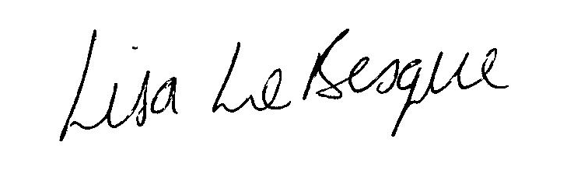

Signature :
Josie Falco
Approved by Head of Service (print name):
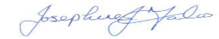
Signature :
Date:
3 Nov 22

